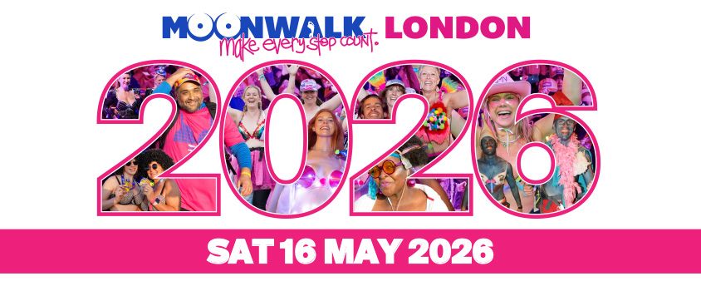

Zoe’s BREAST Friends
We have come together as a team this year as we all have Zoe in common. She is the best mum, friend, sister, daughter, aunty to us and at the end of last year was diagnosed with stage 3 HER2 positive breast cancer & is in treatment. But we will also do it for us all. Everyone will have a mum, friend, sister, daughter, aunty who has/had or will have breast cancer.

Zoe grew up in Farnham Common and went to this school, she has remained very much part of the village over the years and our team is full of Mums who have or had kids in the school.

Raising funds for all cancers is vital. It was only 20 years ago that they found a treatment for the type of breast cancer Zoe has. Things are changing and advancing all the time and we can help make a difference.

Tomorrow night 22 of us take on the 26.2-mile MoonWalk starting at 11pm.
We are on a fundraising mission and if you can support us, please do …every little helps!

https://giving.give-star.com/microsite/walkthewalk/themoonwalklondon2026/team/365d9d64-3332-4e8a-a82d-e4c6e05629f7
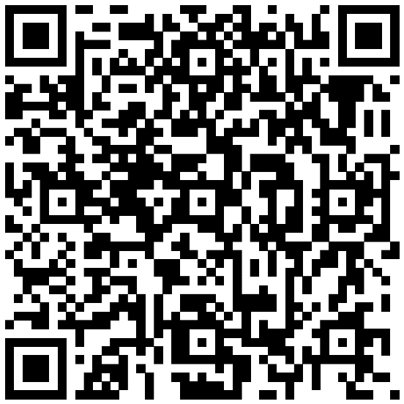

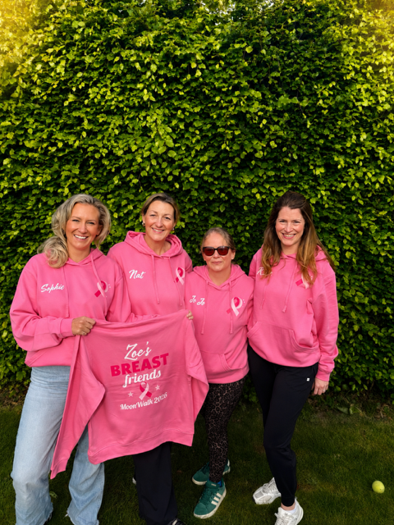

Do you recognise these ladies?
If you know us …. you know what to do! xxx

